Regional CHA Formatting
Fonts:
Normal: Tw Cen MT, Size 12
Footnote: Tw Cen MT, Size 9
Footnote Hyperlink: Tw Cen MT, Size 9, Italic, Underlined, Green Standard Color

Heading 1: Tw Cen MT, Size 12, Bold

Heading 2: Tw Cen MT, Size 12

Heading 3: Tw Cen MT, Size 12

Heading 4: Tw Cen MT, Size 12, Color #4E6E1E
Bold Normal Text: Tw Cen MT, Size 12, Bold
Figure/Table: Tw Cen MT, Size 12, Bold, Color #75A42E
Green Chart Bold Font: Tw Cen MT, Size 10, Bold
Green Chart Data Font: Tw Cen MT, Size 10
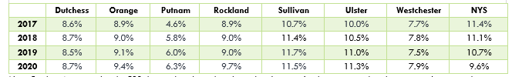
Note/Source: Tw Cen MT, Size 10, Italic
Hyperlink for Figure/Table Source: Tw Cen MT, Size 10, Italic, Green Standard Color
            - TW Cen MT, Size 12

Figure Fonts:
Figure title: Tw Cen MT, Size 14
X and Y Axis Labels: Tw Cen MT, Size 10
X and Y axis Numbers: Tw Cen MT, Size 9
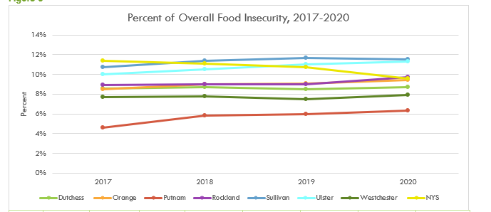

Footnotes:
To insert footnote:
- Click at end of sentence.
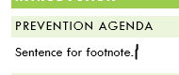
- Click on the References tab in word document and click on insert footnote
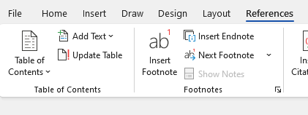

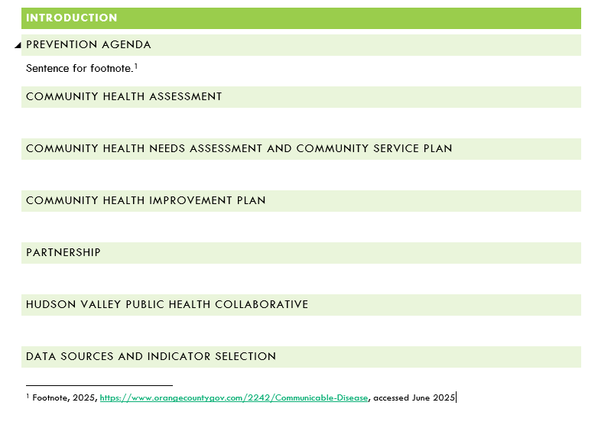
- When you click to insert footnote, it will automatically number and add the space for the actual footnote at bottom of page. Then type in footnote.

- To triple check that you are correct, put your cursor after the footnote number, then hit Footnote in the styles. It should correct if for you.

Graph Plopping:
- Open excel spreadsheet in app (not in teams or browser)
- Click the chart you want to copy
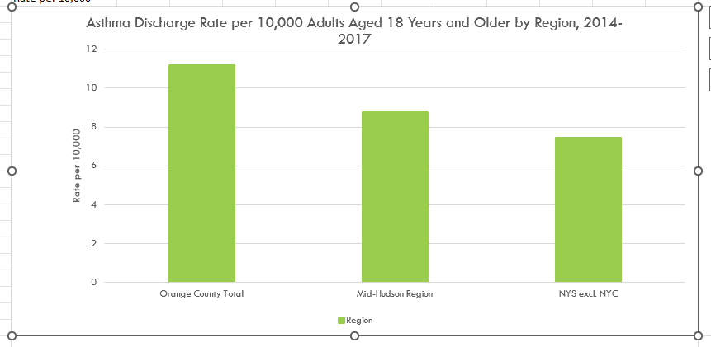

- Hit “Ctrl C” on keyboard
- Click where you want the chart in the document
- Hit “Ctrl V” on keyboard and the chart will be automatically in the document
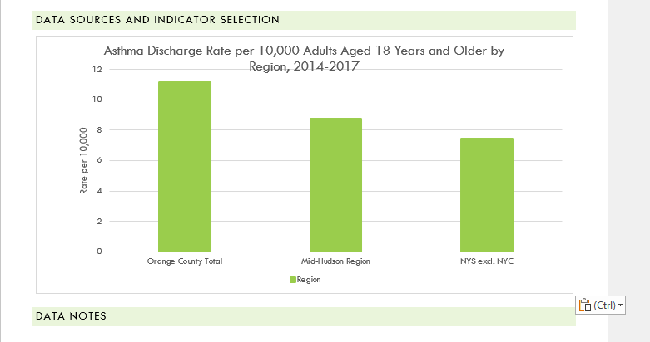

Inserting Figure/Table Numbers:
- Click on the “References” tab in document.
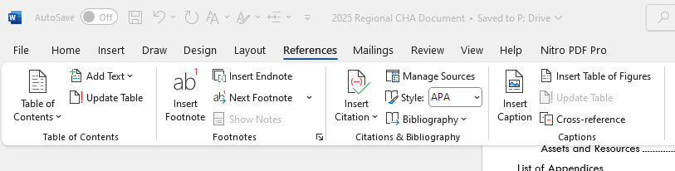

- Click “Insert Caption”


- Select “Figure” or “Table” then hit “okay”.
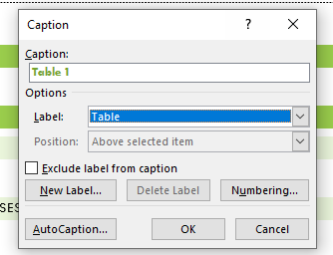
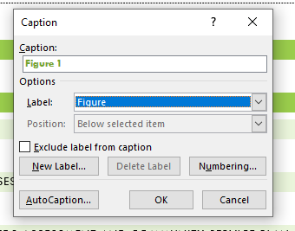

- It will then automatically insert into document.


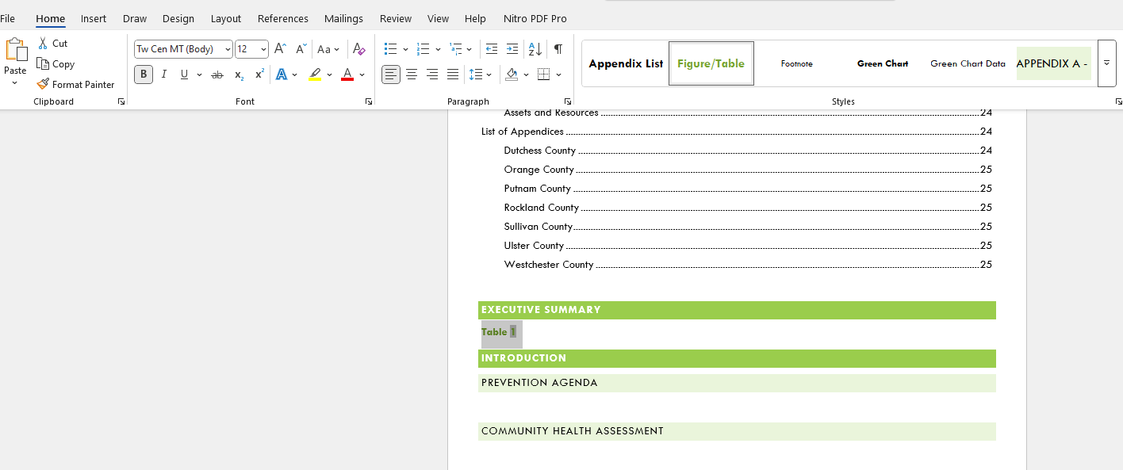
- Go to “Home” tab and highlight “Table 1” and select “Figure/Table” from the font styles to get correct font sizing.

To update Figure/Table Numbers:
- If numbers for the Figures/Tables get messed up, go to the “References” tab and select “Update Table”
